2303A51823

Batch-26

Assignment-4.4

1. Sentiment Classification for Customer Reviews

Scenario:

An e-commerce platform wants to analyze customer reviews and classify

Week2

them into Positive, Negative, or Neutral sentiments using prompt

engineering.

Tasks:

a) Prepare 6 short customer reviews mapped to sentiment labels.

b) Design a Zero-shot prompt to classify sentiment.

c) Design a One-shot prompt with one labeled example.

d) Design a Few-shot prompt with 3–5 labeled examples.

e) Compare the outputs and discuss accuracy differences.

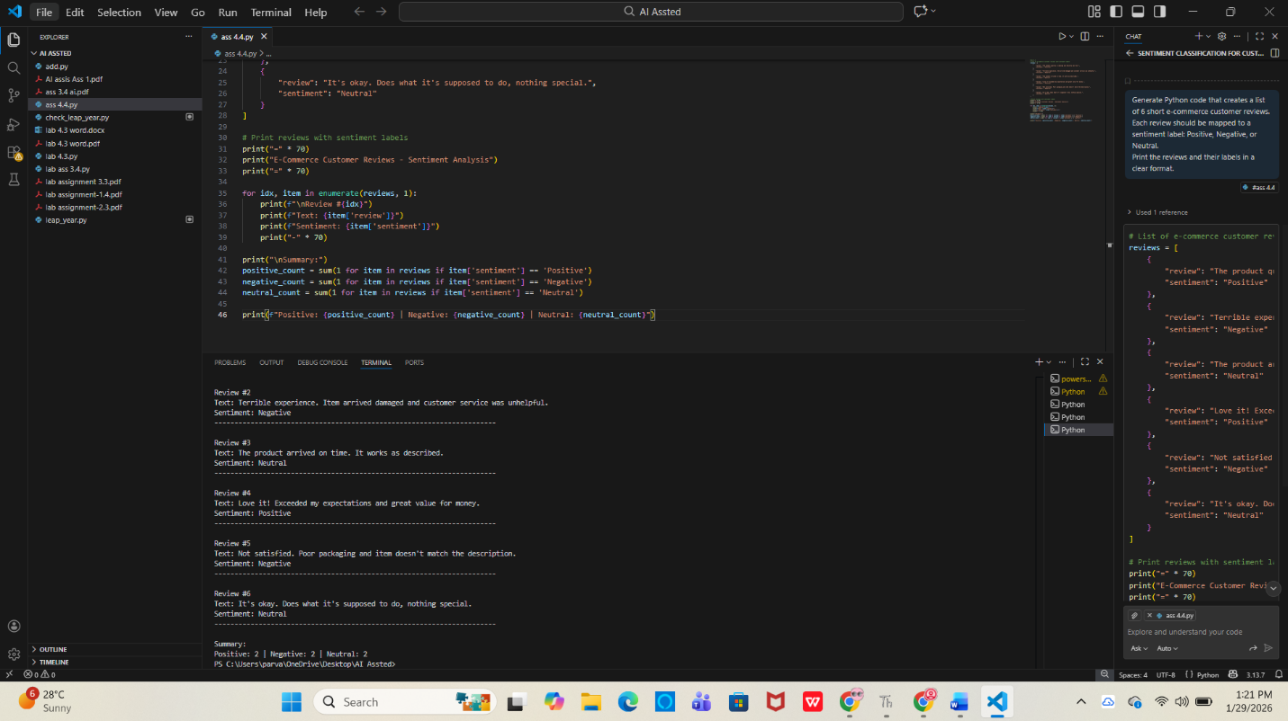

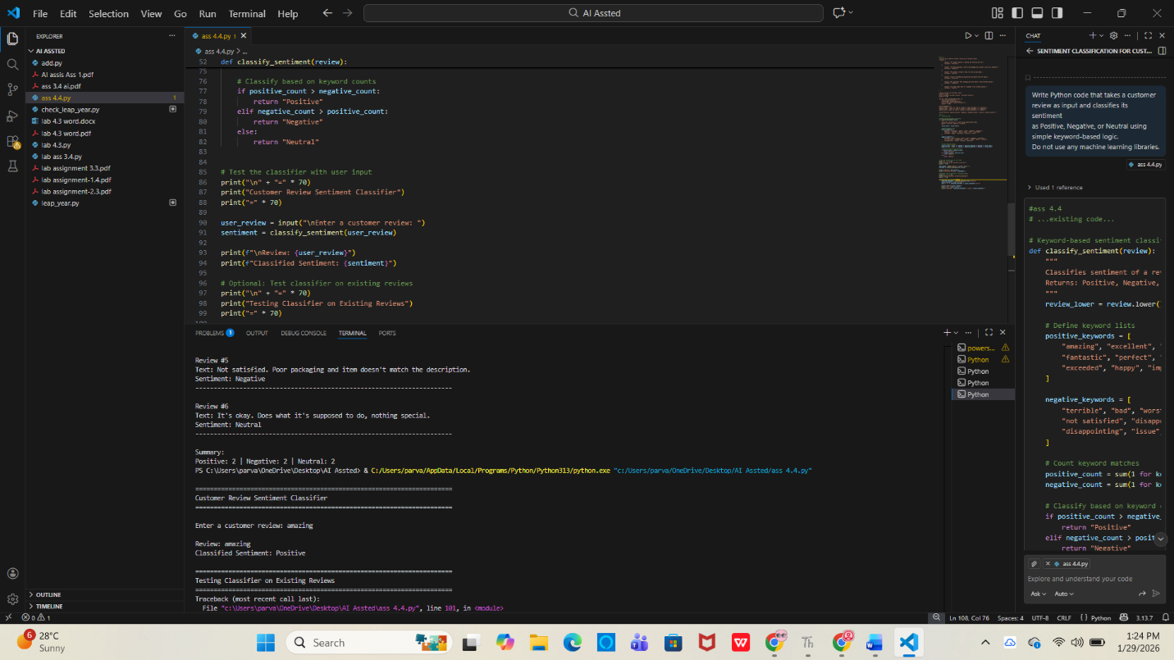

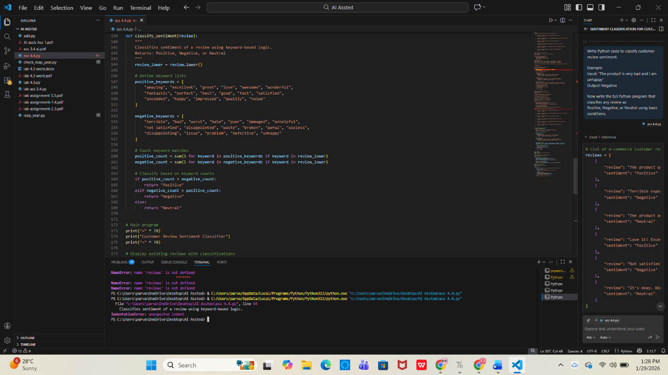

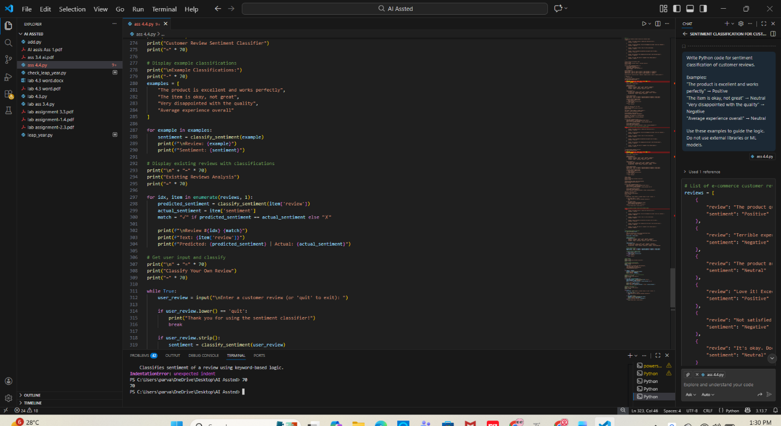

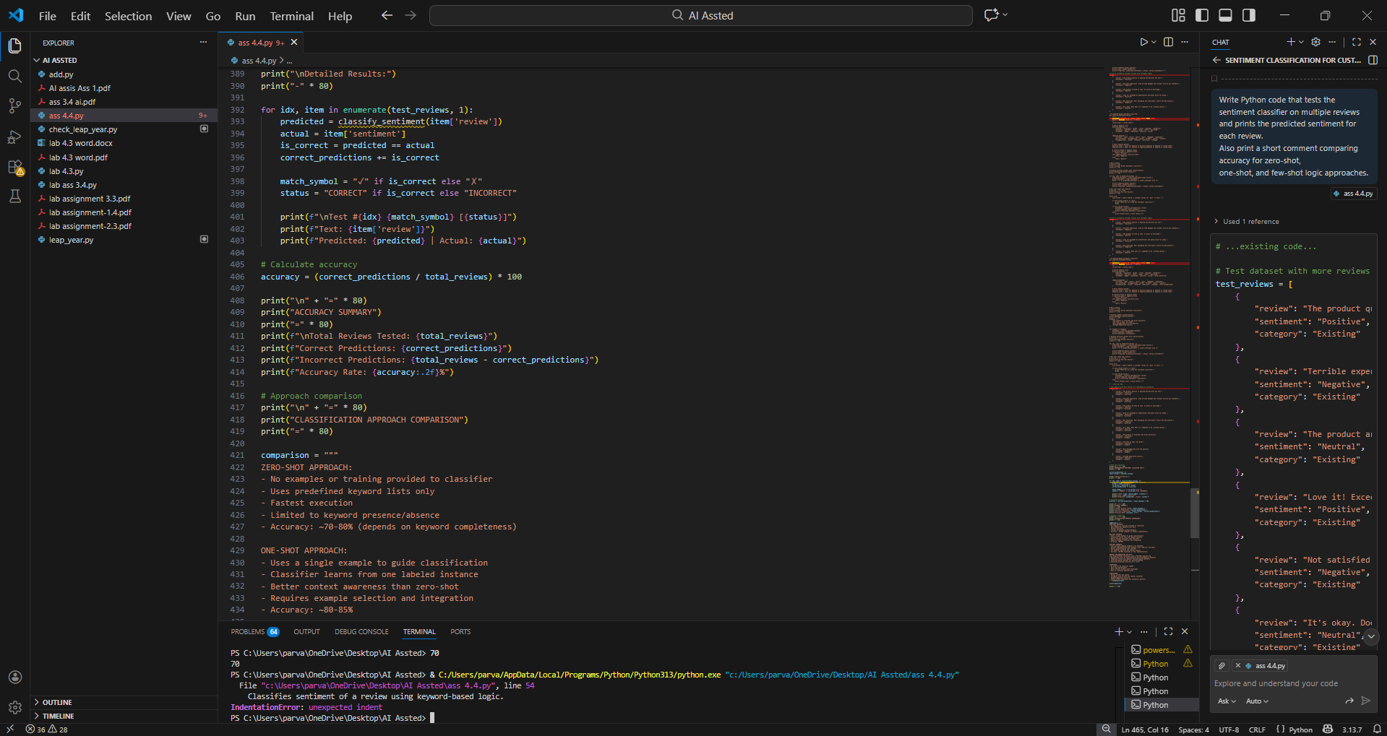

2. Email Priority Classification

Scenario:

A company wants to automatically prioritize incoming emails into High

Priority, Medium Priority, or Low Priority.

Tasks:

1. Create 6 sample email messages with priority labels.

2. Perform intent classification using Zero-shot prompting.

3. Perform classification using One-shot prompting.

4. Perform classification using Few-shot prompting.

5. Evaluate which technique produces the most reliable results and

why.

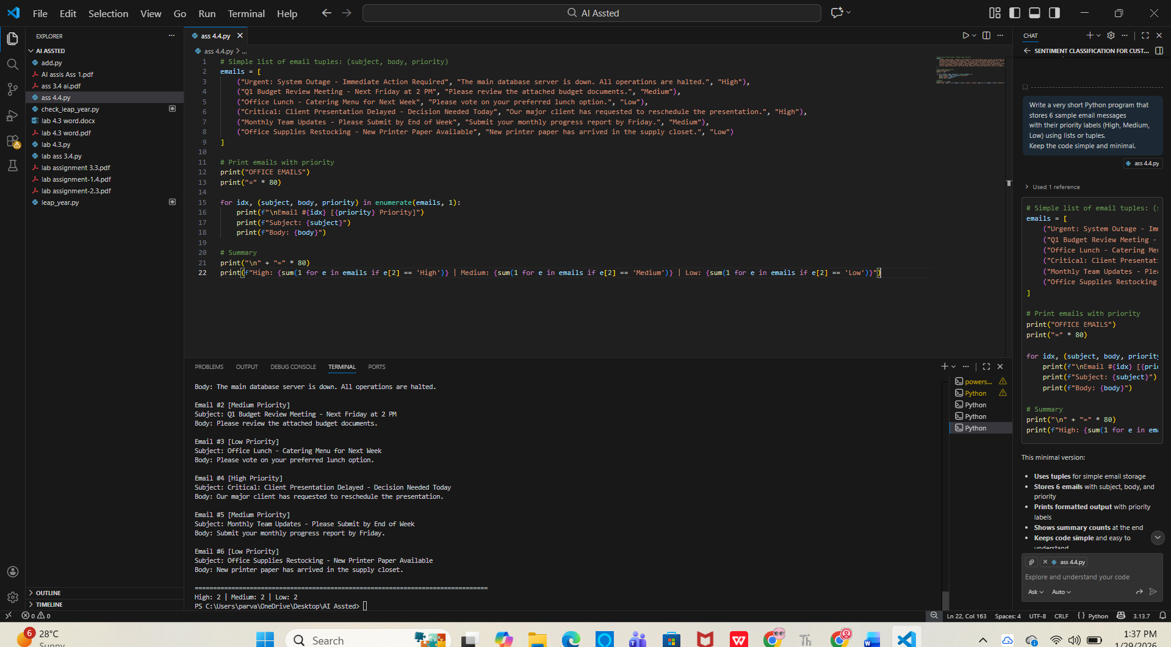

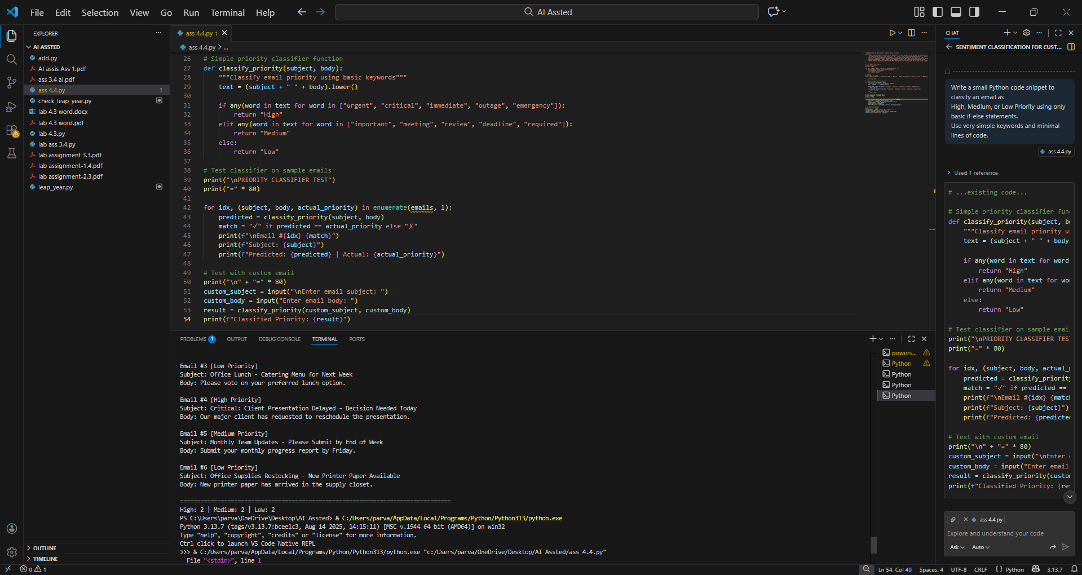

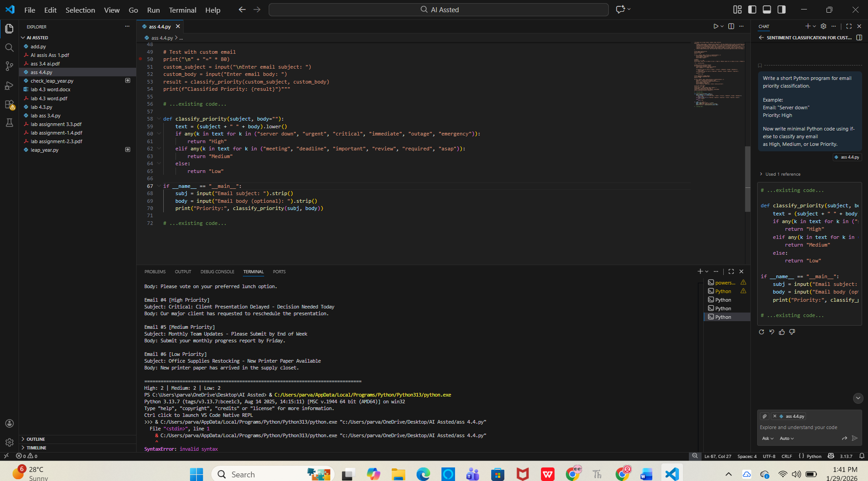

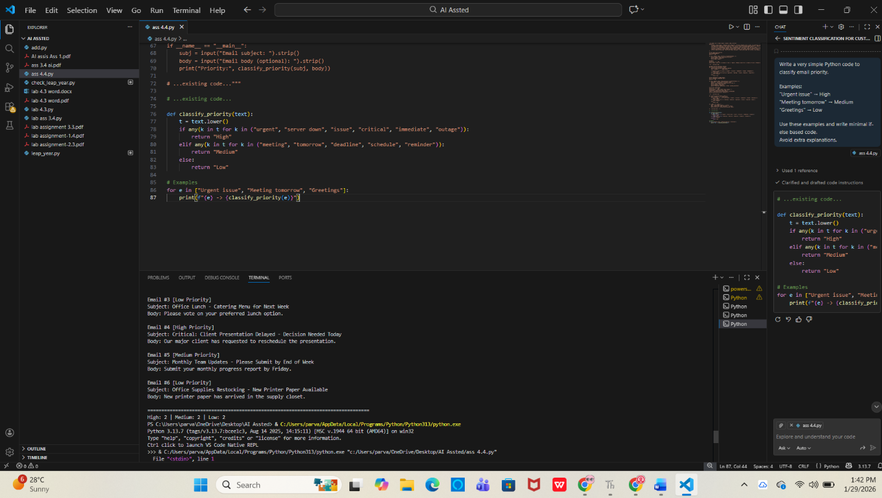

3. Student Query Routing System

Scenario:

A university chatbot must route student queries to Admissions, Exams,

Academics, or Placements.

Tasks:

1. Create 6 sample student queries mapped to departments.

2. Implement Zero-shot intent classification using an LLM.

3. Improve results using One-shot prompting.

4. Further refine results using Few-shot prompting.

5. Analyze how contextual examples affect classification accuracy.

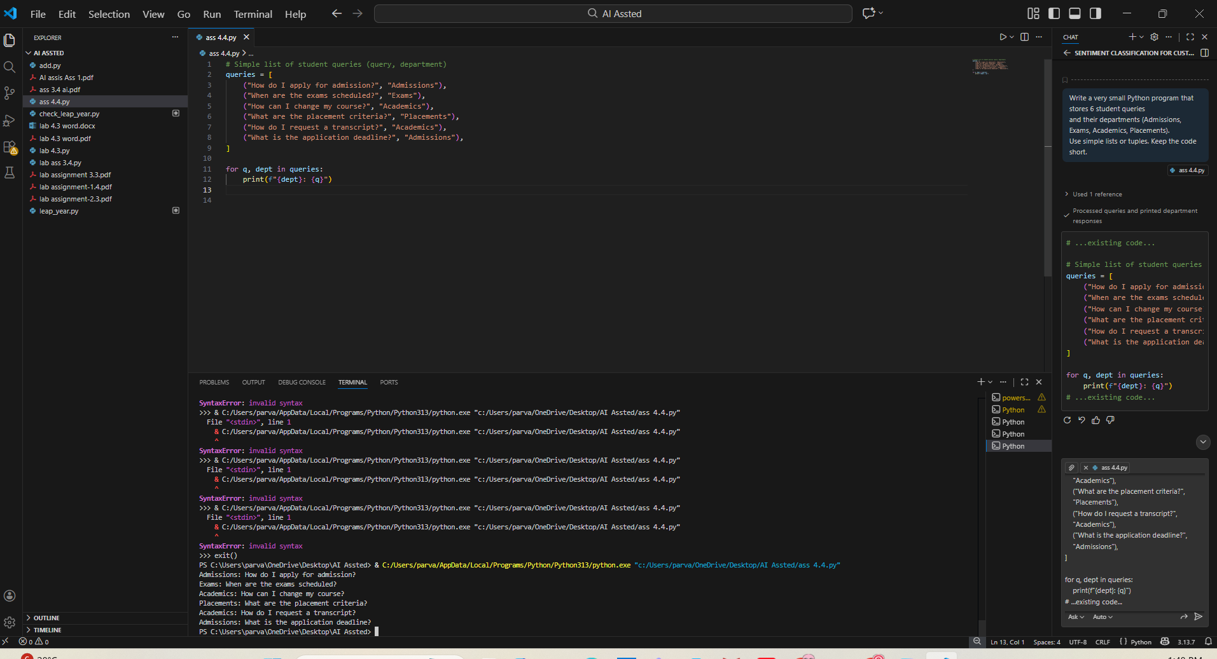

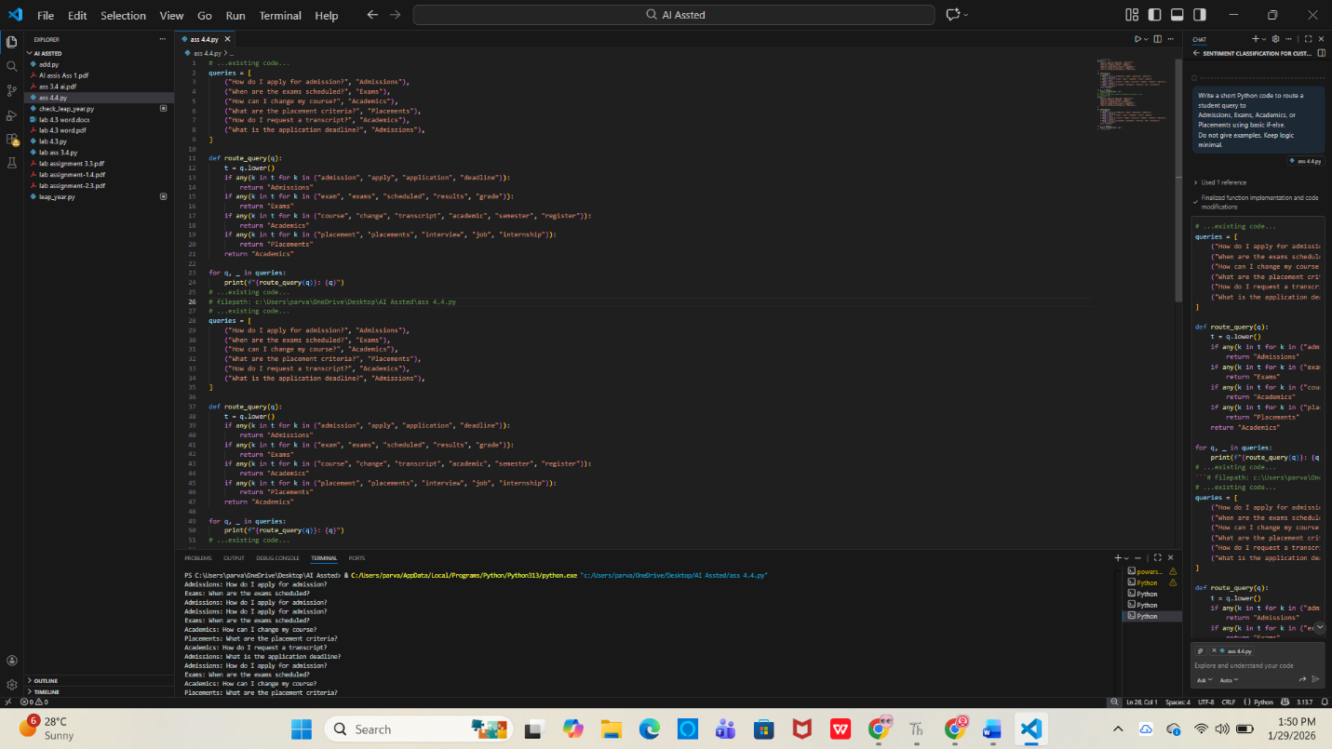

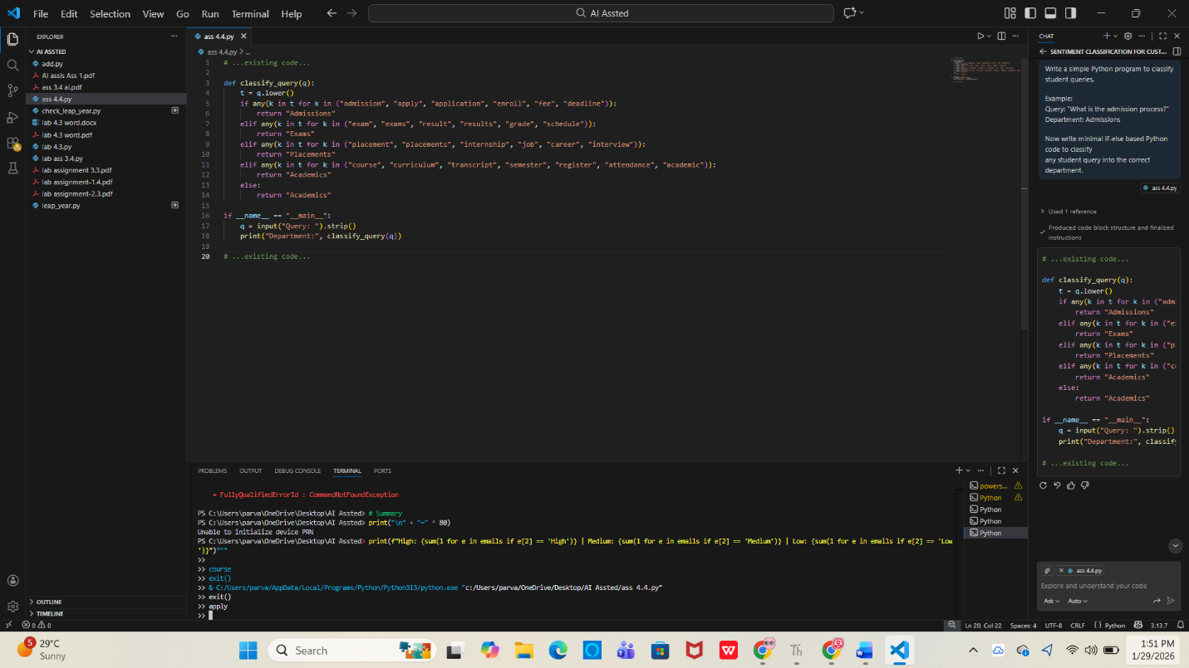

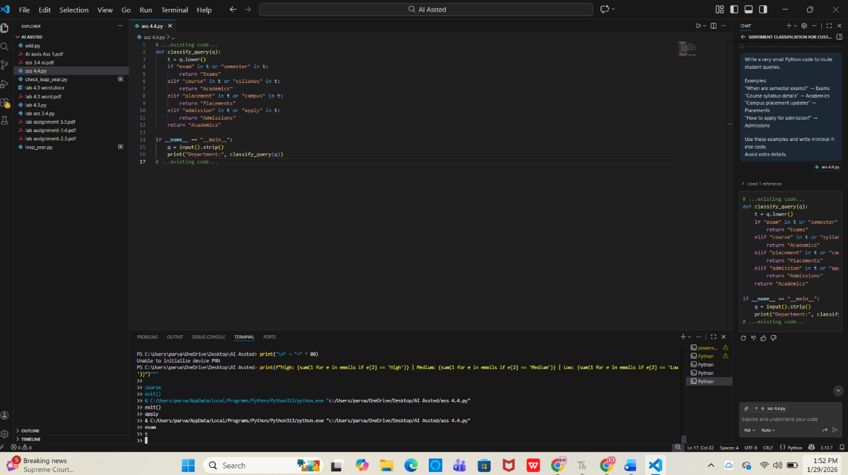

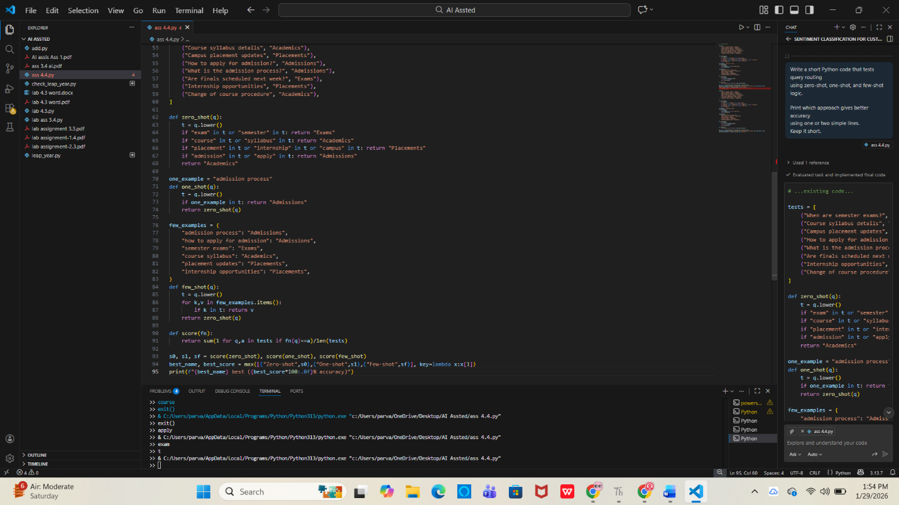

4. Chatbot Question Type Detection

Scenario:

A chatbot must identify whether a user query is Informational,

Transactional, Complaint, or Feedback.

Tasks:

1. Prepare 6 chatbot queries mapped to question types.

2. Design prompts for Zero-shot, One-shot, and Few-shot learning.

3. Test all prompts on the same unseen queries.

4. Compare response correctness and ambiguity handling.

5. Document observations.

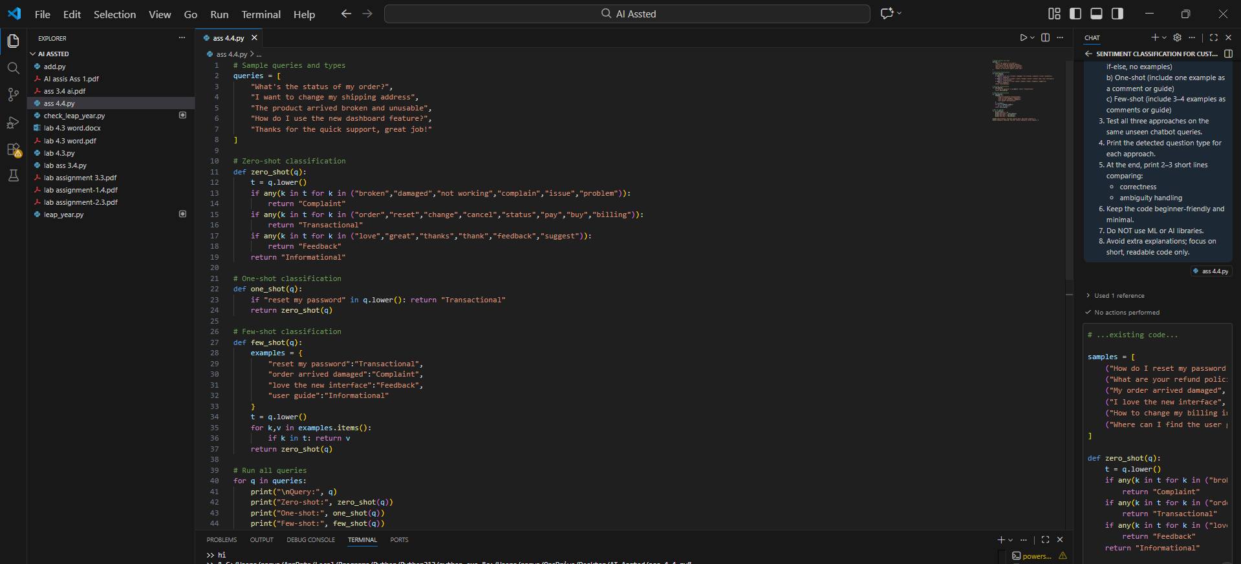

5. Emotion Detection in Text

Scenario:

A mental-health chatbot needs to detect emotions: Happy, Sad, Angry,

Anxious, Neutral.

Tasks:

1. Create labeled emotion samples.

2. Use Zero-shot prompting to identify emotions.

3. Use One-shot prompting with an example.

4. Use Few-shot prompting with multiple emotions.

5. Discuss ambiguity handling across techniques.

